Day51&52 - Task27 - Docker(Part-2)
- Create a tomcat container on 8080 and deploy sample application in tomcat.

- Pull the Tomcat image
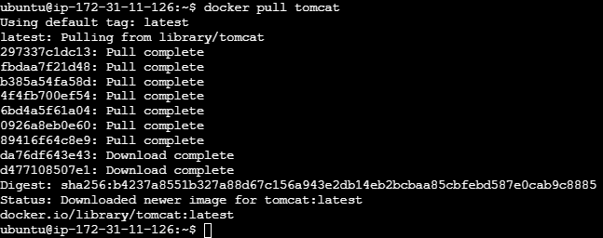
- Create and run the Tomcat container
- Check the running container
- Create a WAR file
- Install Maven on the server to create a package
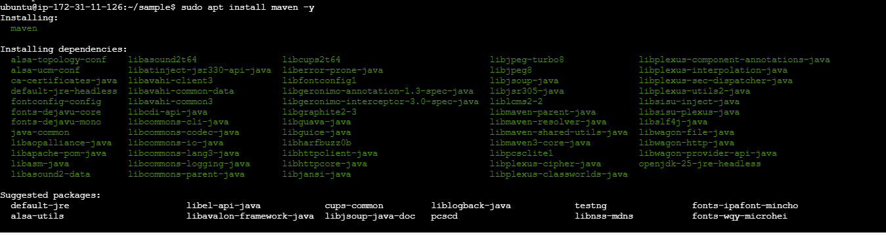
- Create a basic java web application using Maven
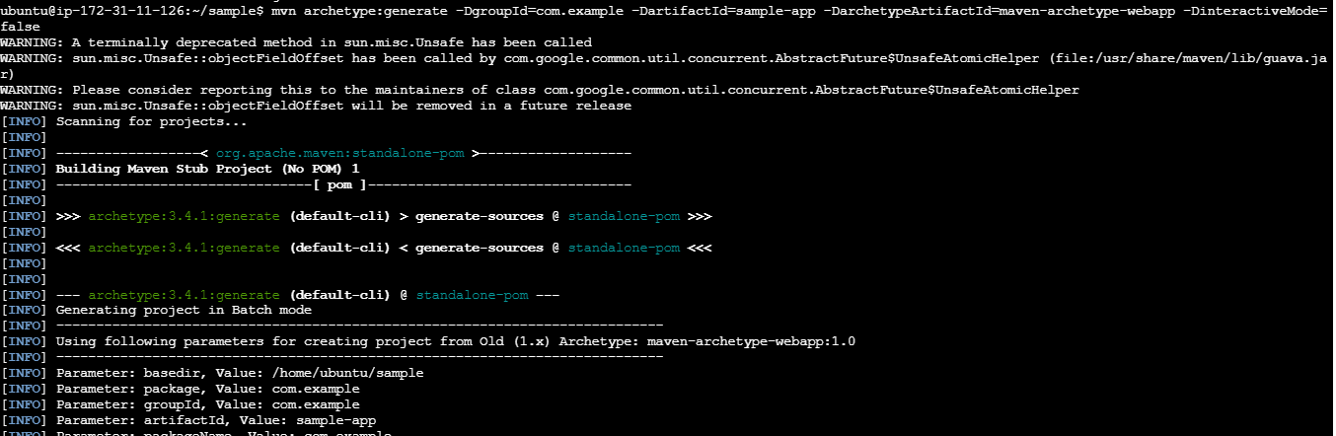
- Now go into sample-app and build a .war file
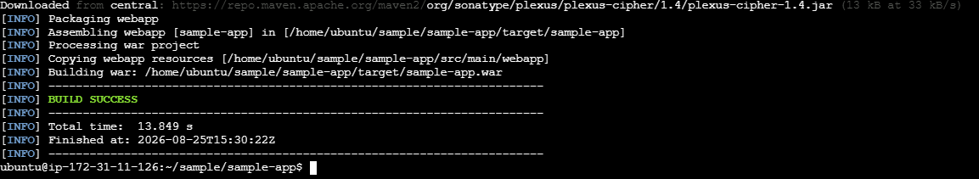
- Copy sample-app.war into Tomcat and verify it
- Then access it on browser:
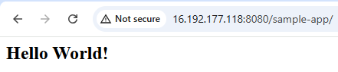
2. Create volume and deploy tomcat container on port 8081.

- Create a Docker volume
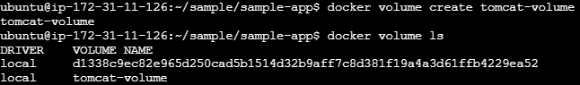
- Create and run Tomcat on port 8081 and verify it
- Test Tomcat

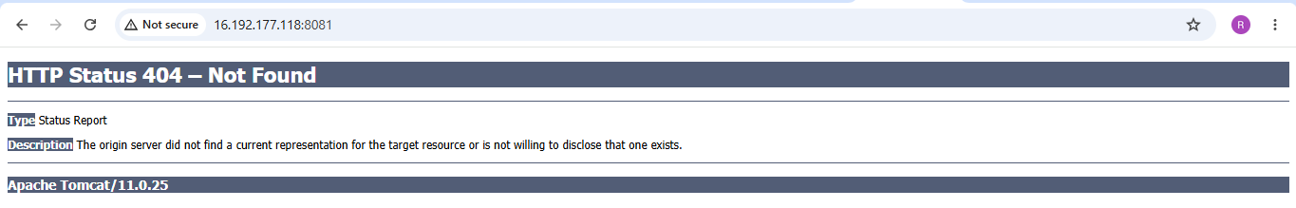

3. Limit the nginx container to 500 MB.
- Pull the Nginx image
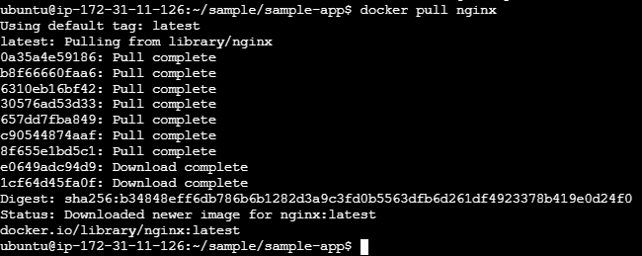
- Run Nginx with a 500 MB memory limit on port 8082 and verify the container
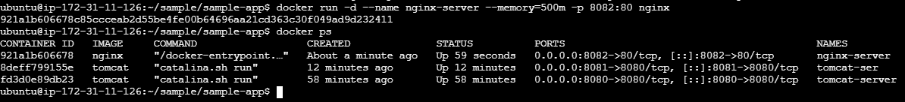
- Check the memory limit
4. Create a sample docker file using below instructions.
- Base module as amazonlinux:latest
- Maintainer you name
- Install nginx
- COPY one index.html file to image
- Expose on port 80
- Command to start the nginx container

- Create a directory, enter directory and create index.html with vi
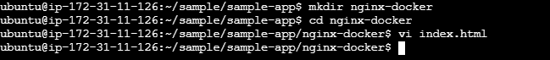

- Create the Dockerfile
- Using vi create a dockerfile and the script into the file
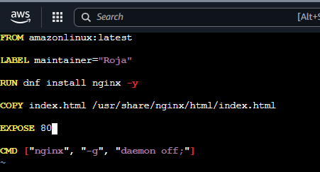

Build the Docker image

- Run this from the directory containing Dockerfile and index.html:
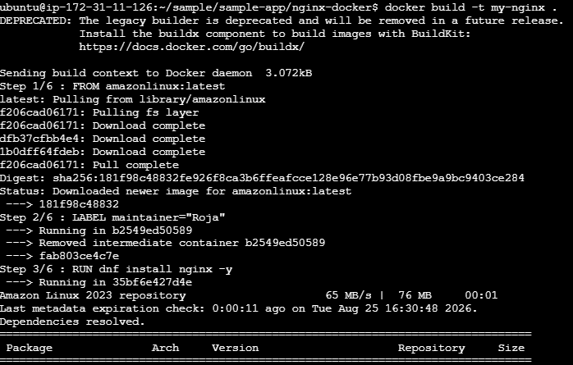
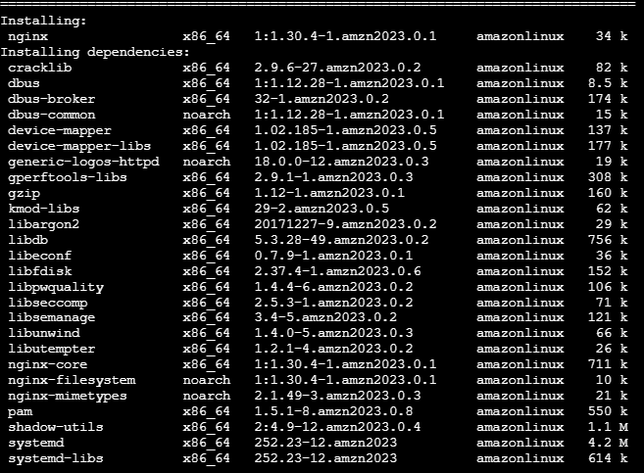
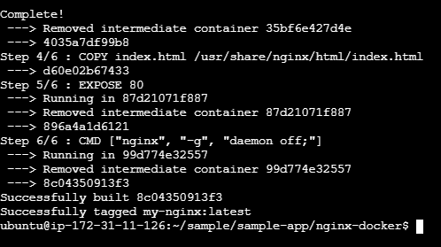

- Check the image
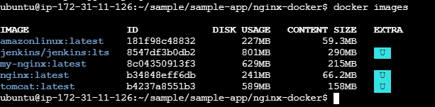

- Create and start the container and check the container
- Test Nginx

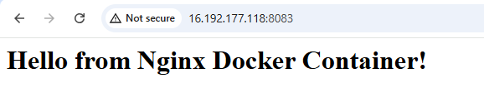

5. Push image to Docker hub

- Create a Docker Hub account
- Go to the docker-hub website and create a free account.
Choose a Docker ID/username. For example:
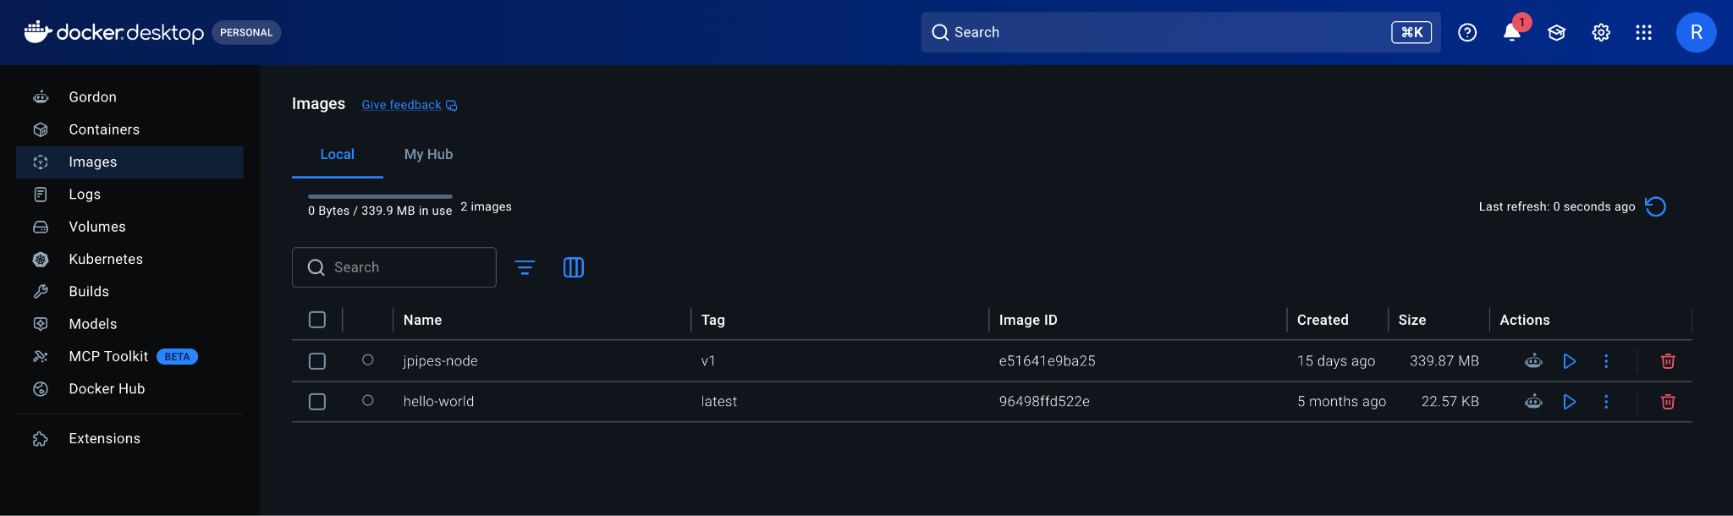
- Create an Access Token
- After logging in to Docker Hub: Profile → Account Settings → Personal access tokens → Generate new token
- Give the token permission to Read & Write.

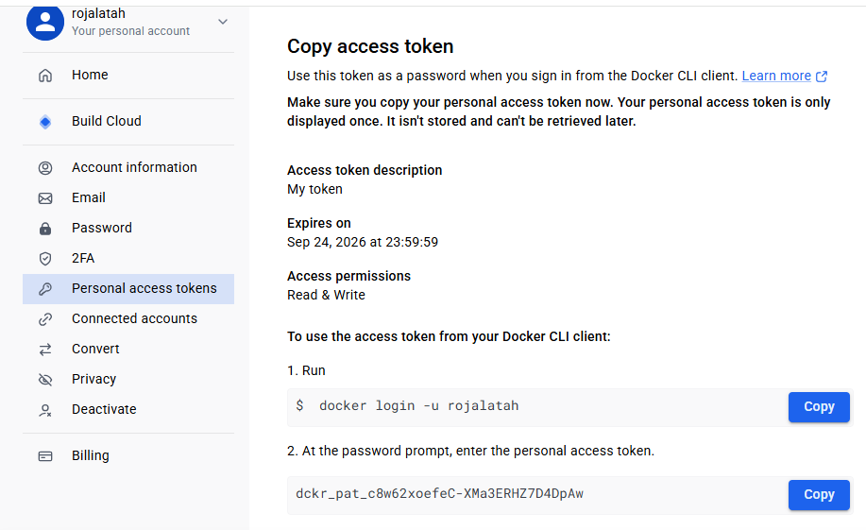
- Login from Ubuntu
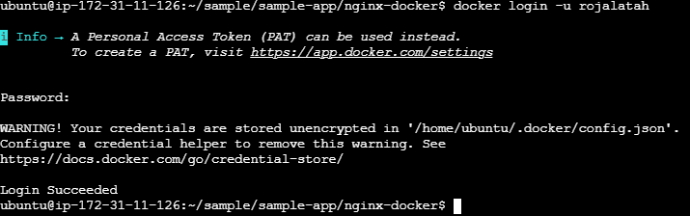
- Tag your image and push the image to docker-hub

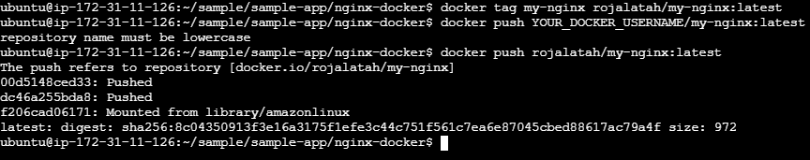
- Verify docker image in local
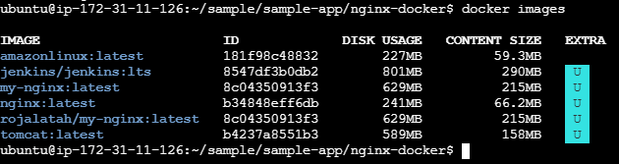
- Verify image on Docker-hub


6. Push image to AWS ECR
- Configure AWS CLI
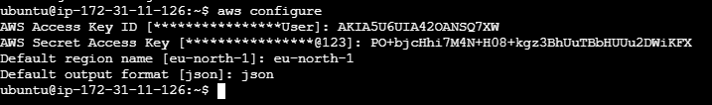
- Create an ECR repository
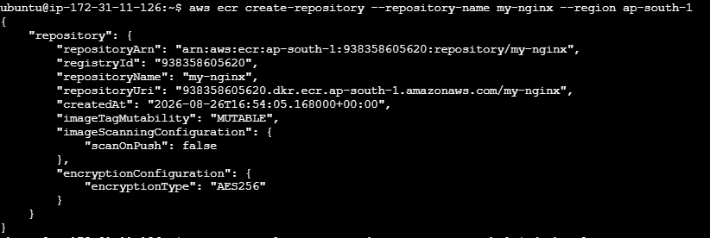
- Login to ECR
- Tag your Docker image and verify the images

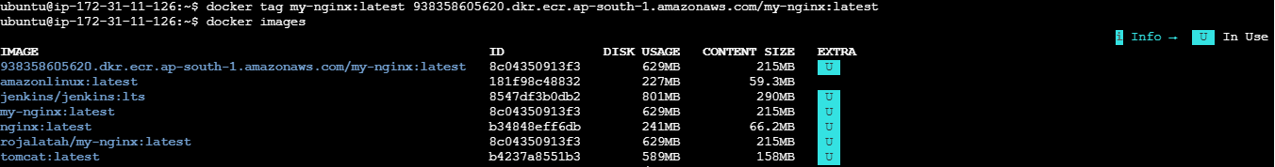
- Push the image and Verify the image in ECR
Docker will upload the image layers to your ECR repository
